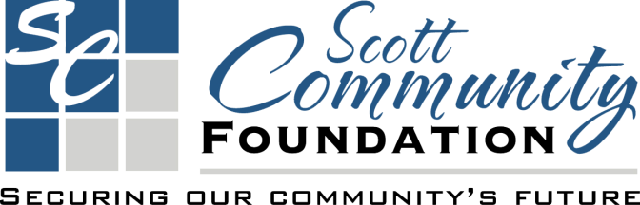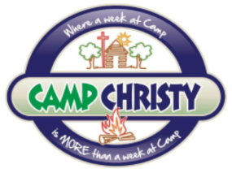

Hello friends of Camp Christy!
It’s that time of year again! The 6th Annual Scott Community Foundation Giving Day is November 15th and Camp Christy is participating.

For the past two years we have raised funds through the Foundation for programing. The total for these three Giving Days was $24,562.

These funds have been vital to the ministry at Camp Christy as it has funded above and beyond what we can do through registration costs alone.

Accomplishments of the Camp Christy Programming Budget funded through Giving Day in 2022:

- Purchase adequate and engaging supplies for Special Needs Camp, Family Camp, and Archery Camp.
- Pay the Camp Christy Worship Team.
- Pay a qualified nurse for one additional week of camp.
- Pay the salary of the Assistant Program Manager.
- Give bonuses for cabin leaders who stayed for additional weeks of camp.
- Help with some repair costs to the swimming pool.
- Purchase digital and paper materials for year-long Bible Study for Legacy Leadership Team.
- Fund Legacy Leadership Weekends.
- Held our first freezer meal cooking retreat.
- Held/Scheduled our first two Homeschool Days.

We have an exciting development at Camp Christy which might also benefit from the Giving Day Programming Fundraiser! That development is the addition of a horse ministry!

We have been working along side a family in Scott City who is wanting to partner with us to bring horses back to Camp Christy to be used in year long ministry. In order to get this ministry off the ground we need to build fencing to corral the horses, a shelter/storage building, and purchase other tack and educational equine activities. Our partners, Clay and Emily Mulligan, also plan to fundraise but we hope to be able to get some, if not all of our start-up costs through Giving Day!

As always, we dream big and hope you dream with us. Below are some ideas we have had on future programming.

Continued Archery Camps
Continued Special Needs Camp-
Continued Women’s Self-Defense Camp
Continued Men’s and Women’s Journey Camps
Men’s Defender Camp
Men’s and Women’s Retreats
Praise and Worship Camp
Sports Camps
Canvas Art classes
Freezer Meal Cooking Retreats
Horse/Animal Programs
Hunter Safety Courses/Camps
Marriage Retreats
Camps for foster children/families
Fundraising events
Etc.…

Bonus Funds will be given be given based off of total donations and amount raised.
Our Goal is to raise at least $10,000 for Camp Christy Programming!

How you can help Camp Christy!
- Make a donation through the Scott Community Foundation. (Starting as small as $10) to Camp Christy on November 15th, 2022, in person at the Scott Community Foundation or online at https://www.scottcf.org/giving-day 8AM and 5 p.m. Write your checks to Scott Community Foundation and write “Camp Christy Fund” in the memo.
- Make a Donation directly to Camp Christy. You can also donate directly to Camp Christy any time by writing a check or donating securely at https://www.campchristy.net/online-giving.
- Spread the word. Tell your friends, post on Facebook, and tweet about it. This is an opportunity to, be a part of a community building event!

If you want to watch the excitement surrounding this day you can log onto https://www.scottcf.org/giving-day and watch the total number and value of donations climb. You can also follow at Camp Christy or Scott Community Foundation’s Facebook, Camp Christy(@CampChristy3) or SCF(@CommunityScott) on Twitter or tune into 94.5!

Give where you live and support local nonprofits, especially Camp Christy as we are doing the work of Jesus!

Thank you,

Camp Christy Board of Directors
Freddy Moore-President
Tonya Koehn-Secretary
Janice Storm-Treasure
Bob Artz
Becky Rider
Cindy Cramer
Amy Elmore
Gary Simon
Gabe Flaska
Rishawn Austin
Theresa Salmons

Steven and Danielle Massaglia
Camp Christy Managers
620-872-3025
campchristy365@gmail.com
320 Camp Christy Drive
Scott City, KS 67871

